Supplementary materials for

**Synthesis and Physicochemical Properties of Hydrazides**

**of Malonic Acid with Different Substitutes**

**T.V. Ghochikyan, A.I. Martiryan, G.A. Shahinyan, M.A. Samvelyan\*,**

**A.S. Galstyan, H․R. Sargsyan, H․H. Ghazoyan**

Yerevan State University, 1/1 A. Manoukyan Str., Yerevan, 0025, Armenia

\*E-mail: [msamvelyan@ysu.am](mailto:msamvelyan@ysu.am)

**Keywords:** Intramolecular cyclization; Hydrazide hydrates; Butanolide; Antioxidant activity

**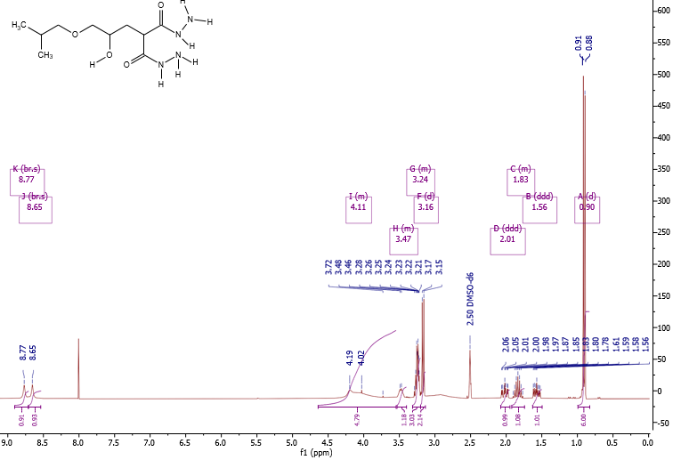**

**Fig. S-1**. 1H–NMR-spectrum of **2a** (300 MHz, DMSO/CCl4 - 1/3).

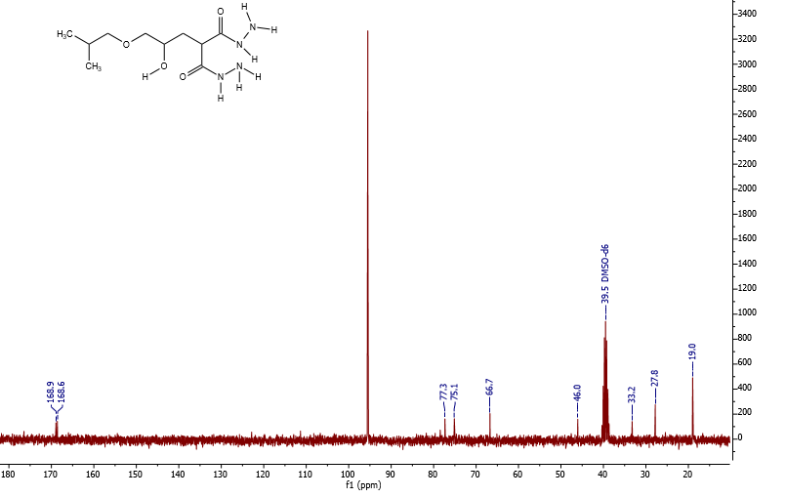

**Fig. S-2.** 13C-NMR-spectrum of **2a** (75 MHz, DMSO/CCl4 - 1/3).

**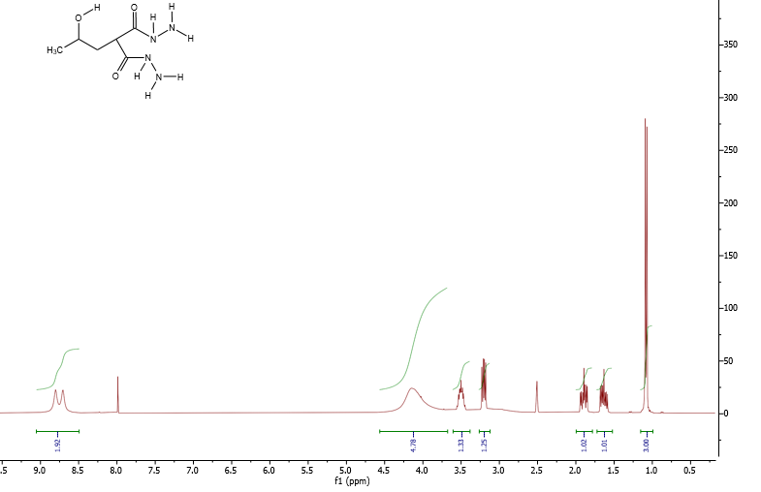**

**Fig. S-3.** 1H–NMR-spectrum of **2b** (300 MHz, DMSO/CCl4 - 1/3).

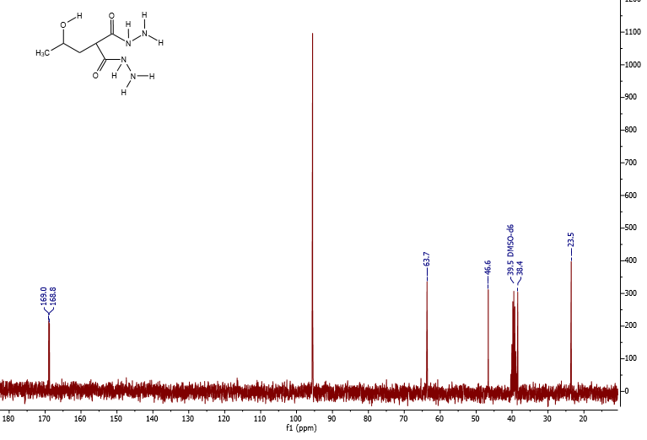

**Fig. S-4.** 13C-NMR-spectrum of **2b** (75 MHz, DMSO/CCl4 - 1/3).

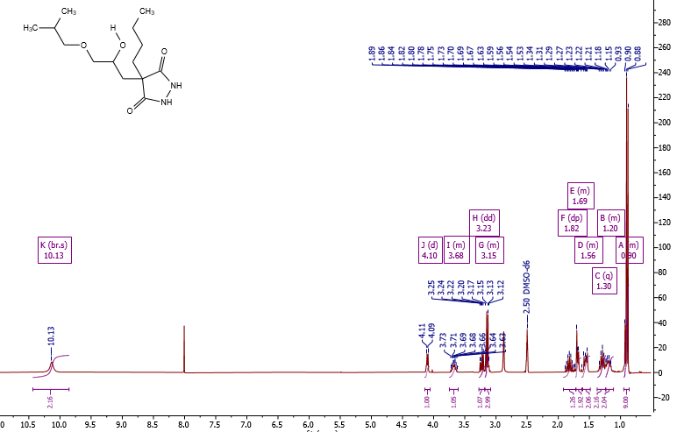

**Fig. S-5.** 1H- NMR-spectrum of **2c** (300 MHz, DMSO/CCl4 - 1/3).

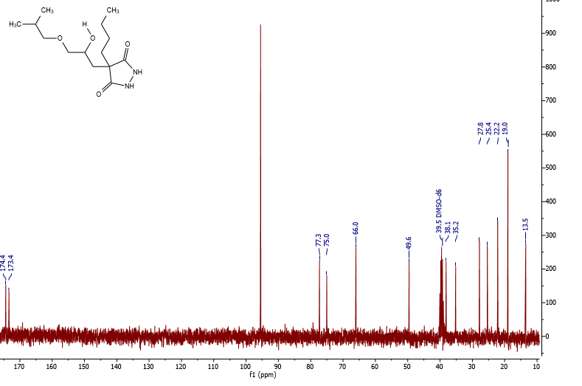

**Fig. S-6**. 13C- NMR-spectrum of **2c** (75 MHz, DMSO/CCl4 - 1/3).

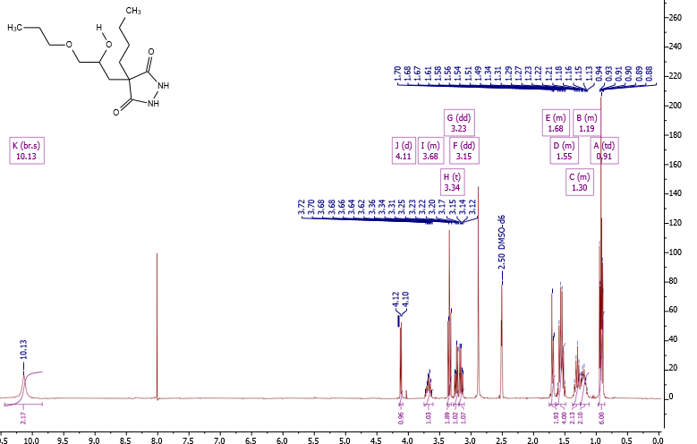

**Fig. S-7**. 1H-NMR-spectrum of **2d** (300 MHz, DMSO/CCl4 - 1/3).

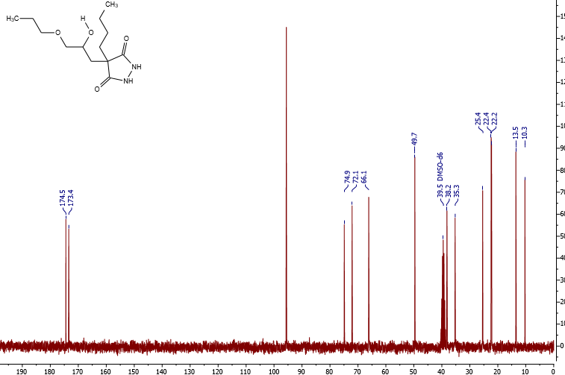

**Fig. S-8.** 13C-NMR-spectrum of **2d** (75 MHz, DMSO/CCl4 - 1/3).

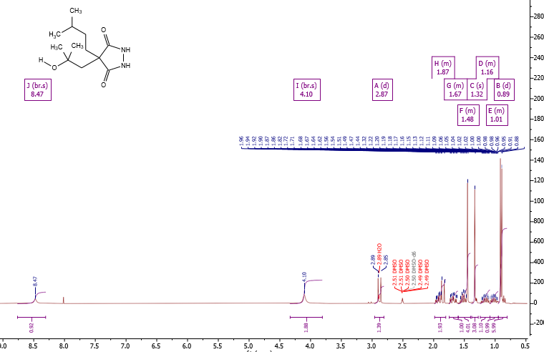

**Fig. S-9.** 1H –NMR-spectrum of **2e** (300 MHz, DMSO/CCl4 - 1/3).

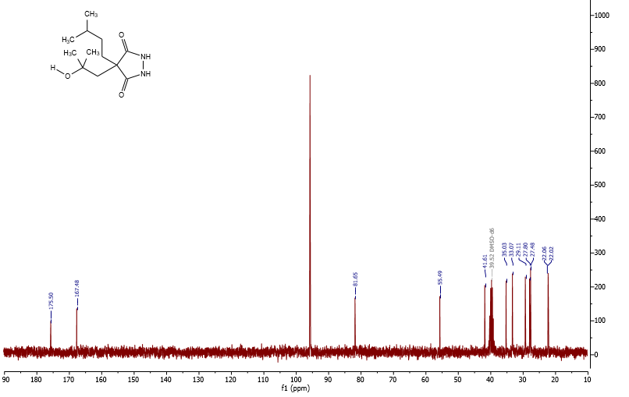

**Fig. S-10.** 13C-NMR-spectrum of **2e** (75 MHz, DMSO/CCl4 - 1/3).



**Fig. S-11.** The intensity-weighted size distribution of **2a** at 298.15 K.



**Fig. S-12.** The intensity-weighted size distribution of **2b** at 298.15 K.



**Fig. S-13.** The intensity-weighted size distribution of **2c** at 298.15 K.



**Fig. S-14.** Absorption of PNDMA vs time of radiation of hydrogen peroxide at the presence of **2a.**

****

**Fig. S-15.** Absorption of PNDMA vs time of radiation of hydrogen peroxide at the presence of **2b**.



**Fig. S-16.** Absorption of PNDMA vs time of radiation of hydrogen peroxide at the presence of **2c.**



**Fig. S-17**. Absorption of PNDMA vs time of radiation of hydrogen peroxide at the presence of **2d**.

C:\Users\DELL\Desktop\ECTJ_4_2024\T. V. Ghochikyan\рисунки\SM\Fig. S18.tif

**Fig. S-18.** Absorption of PNDMA vs time of radiation of hydrogen peroxide at the presence of **2e**.