Supplementary Material for
https://doi.org/10.18321/ectj1679

Investigation of the Kinetics of Cotton Soapstock Saponification under Ultrasonic Illumination

Sanjarbek Shamuratov¹*, Umarbek Alimov^{1,2}*, Mohamed Rifky³*, Umidbek Baltaev¹,
Мavlyuda Ibragimova², Sherzod Kurambaev¹, Мansur Radjabov¹

¹Urgench State University, 14, Khamid Alimdjan, Urgench, 220100, Uzbekistan
²Institute of General and Inorganic Chemistry, Academy of Sciences of the Republic of Uzbekistan,
77a, Mirzo Ulugbek, Tashkent, Uzbekistan.
³Eastern University, Sri Lanka, Chenkalady, 30350, Sri Lanka

Table S1. Dependence of the change in the rate constant and FA of cotton soapstock on the mixing time and temperature by the convention method

Temperature, K | Time (τ), min |  | Consumption of HCl for titration of St. NaOH ml | FA, % |  | Saponification extent, % | Rate constant of saponification, K, τ⁻¹ | lgK | lgC/(C₀-C_{τ})
1 | 2 |  |  | 3 |  | 4 | 5 | 6 | 7
338 | 15 |  | 16,60 | 2,21 |  | 74,11 | 0,09 | -1,05 | 1,41
338 | 30 |  | 16,60 | 2,21 |  | 74,03 | 0,04 | -1,35 | 1,41
338 | 40 |  | 16,50 | 2,20 |  | 74,10 | 0,03 | -1,47 | 1,41
338 | 60 |  | 16,40 | 2,19 |  | 74,21 | 0,02 | -1,65 | 1,41
338 | 75 |  | 16,40 | 2,19 |  | 74,28 | 0,02 | -1,74 | 1,41
338 | 90 |  | 16,40 | 2,18 |  | 74,32 | 0,02 | -1,82 | 1,41
338 | 105 |  | 16,30 | 2,18 |  | 74,36 | 0,01 | -1,89 | 1,41
338 | 120 |  | 16,30 | 2,17 |  | 74,43 | 0,01 | -1,94 | 1,41
Standard Deviation |  |  |  | 0,01 |  | 0,14 | 0,03 | 0,31 | 0,00
Standard Error |  |  |  | 0,01 |  | 0,05 | 0,01 | 0,11 | 0,00
Upper Cl (95%) |  |  |  | 2,20 |  | 74,35 | 0,05 | -1,36 | 1,41
Lower Cl (95%) |  |  |  | 2,18 |  | 74,11 | 0,01 | -1,87 | 1,41
 |  | Average |  |  |  |  | 0,03 | -1,61 | 1,41
348 | 15 |  | 14,00 | 1,87 |  | 78,00 | 0,10 | -1,00 | 1,34
348 | 30 |  | 13,60 | 1,81 |  | 78,71 | 0,05 | -1,29 | 1,33
348 | 40 |  | 13,20 | 1,76 |  | 79,29 | 0,04 | -1,40 | 1,32
348 | 60 |  | 12,90 | 1,72 |  | 79,76 | 0,03 | -1,57 | 1,31
348 | 75 |  | 12,70 | 1,69 |  | 80,12 | 0,02 | -1,67 | 1,30
348 | 90 |  | 12,50 | 1,67 |  | 80,35 | 0,02 | -1,74 | 1,29
348 | 105 |  | 12,10 | 1,61 |  | 81,06 | 0,02 | -1,80 | 1,28
348 | 120 |  | 11,90 | 1,59 |  | 81,29 | 0,01 | -1,85 | 1,27
Standard Deviation |  |  |  | 0,10 |  | 1,13 | 0,03 | 0,29 | 0,02
Standard Error |  |  |  | 0,03 |  | 0,40 | 0,01 | 0,10 | 0,01
Upper Cl (95%) |  |  |  | 1,80 |  | 80,77 | 0,06 | -1,30 | 1,32
Lower Cl (95%) |  |  |  | 1,63 |  | 78,88 | 0,01 | -1,79 | 1,28
 |  | Average |  |  |  |  | 0,04 | -1,54 | 1,30
358 | 15 |  | 8,30 | 1,11 |  | 86,91 | 0,14 | -0,87 | 1,12
358 | 30 |  | 7,90 | 1,05 |  | 87,66 | 0,07 | -1,16 | 1,09
358 | 40 |  | 7,30 | 0,99 |  | 88,58 | 0,05 | -1,27 | 1,06
358 | 60 |  | 7,20 | 0,93 |  | 88,68 | 0,04 | -1,44 | 1,05
358 | 75 |  | 6,40 | 0,85 |  | 89,99 | 0,03 | -1,51 | 1,00
358 | 90 |  | 6,10 | 0,82 |  | 90,39 | 0,03 | -1,58 | 0,98
358 | 105 |  | 5,60 | 0,75 |  | 91,19 | 0,02 | -1,64 | 0,94
358 | 120 |  | 5,30 | 0,71 |  | 91,64 | 0,02 | -1,68 | 0,92
Standard Deviation |  |  |  | 0,14 |  | 1,69 | 0,04 | 0,28 | 0,07
Standard Error |  |  |  | 0,05 |  | 0,60 | 0,01 | 0,10 | 0,02
Upper Cl (95%) |  |  |  | 1,02 |  | 90,79 | 0,08 | -1,16 | 1,08
Lower Cl (95%) |  |  |  | 0,78 |  | 87,97 | 0,02 | -1,63 | 0,96
 |  | Average |  |  |  |  | 0,05 | -1,39 | 1,02
368 | 15 |  | 4,60 | 0,61 |  | 92,84 | 0,18 | -0,75 | 0,85
368 | 30 |  | 4,20 | 0,56 |  | 93,36 | 0,09 | -1,04 | 0,82
368 | 40 |  | 3,90 | 0,51 |  | 93,95 | 0,07 | -1,15 | 0,78
368 | 60 |  | 3,50 | 0,47 |  | 94,49 | 0,05 | -1,32 | 0,74
368 | 75 |  | 3,10 | 0,41 |  | 95,19 | 0,04 | -1,39 | 0,68
368 | 90 |  | 2,50 | 0,33 |  | 96,15 | 0,04 | -1,44 | 0,59
368 | 105 |  | 2,20 | 0,29 |  | 96,60 | 0,03 | -1,49 | 0,53
368 | 120 |  | 2,00 | 0,27 |  | 96,88 | 0,03 | -1,54 | 0,49
Standard Deviation |  |  |  | 0,13 |  | 1,52 | 0,05 | 0,27 | 0,14
Standard Error |  |  |  | 0,04 |  | 0,54 | 0,02 | 0,09 | 0,05
Upper Cl (95%) |  |  |  | 0,54 |  | 96,20 | 0,11 | -1,04 | 0,80
Lower Cl (95%) |  |  |  | 0,33 |  | 93,66 | 0,02 | -1,49 | 0,57
 |  | Average |  |  |  |  | 0,07 | -1,27 | 0,69

Table S2. Dependence of the change in the rate constant and the FA of cotton soapstock on the mixing time and temperature under ultrasonic influence
Temperature,  K | Time (τ), min | Consumption of HCl for titration of St, NaOH ml | FA, % | Saponification extent, % | Rate constant of saponification, K, τ⁻¹ | lgK | lgC/(C₀-C_{τ})
1 | 2 |  | 3 | 4 | 5 | 6 | 7
338 | 15 | 13,50 | 1,80 | 78,78 | 0,10 | -0,99 | 1,33
338 | 30 | 13,30 | 1,77 | 79,13 | 0,05 | -1,28 | 1,32
338 | 40 | 12,80 | 1,71 | 79,93 | 0,04 | -1,40 | 1,30
338 | 60 | 12,70 | 1,69 | 80,11 | 0,03 | -1,57 | 1,30
338 | 75 | 12,50 | 1,67 | 80,33 | 0,02 | -1,66 | 1,29
338 | 90 | 12,30 | 1,64 | 80,66 | 0,02 | -1,74 | 1,29
338 | 105 | 12,20 | 1,63 | 80,81 | 0,02 | -1,80 | 1,28
338 | 120 | 12,20 | 1,63 | 80,86 | 0,01 | -1,86 | 1,28
Standard Deviation |  |  | 0,06 | 0,77 | 0,03 | 0,30 | 0,02
Standard Error |  |  | 0,04 | 0,27 | 0,01 | 0,11 | 0,01
Upper Cl (95%) |  |  | 1,02 | 80,72 | 0,06 | -1,29 | 1,31
Lower Cl (95%) |  |  | 0,82 | 79,43 | 0,01 | -1,79 | 1,29
Average |  |  |  |  | 0,04 | -1,54 | 1,30
348 | 15 | 10,57 | 1,44 | 83,42 | 0,12 | -0,92 | 1,22
348 | 30 | 10,48 | 1,40 | 83,56 | 0,06 | -1,22 | 1,22
348 | 40 | 10,32 | 1,38 | 83,81 | 0,05 | -1,34 | 1,21
348 | 60 | 9,83 | 1,31 | 84,58 | 0,03 | -1,51 | 1,19
348 | 75 | 9,65 | 1,29 | 84,86 | 0,03 | -1,60 | 1,18
348 | 90 | 9,33 | 1,24 | 85,36 | 0,02 | -1,67 | 1,17
348 | 105 | 9,14 | 1,22 | 85,67 | 0,02 | -1,73 | 1,16
348 | 120 | 8,88 | 1,18 | 86,07 | 0,02 | -1,78 | 1,14
Standard Deviation |  |  | 0,09 | 1,00 | 0,03 | 0,29 | 0,03
Standard Error |  |  | 0,03 | 0,35 | 0,01 | 0,10 | 0,01
Upper Cl (95%) |  |  | 1,38 | 85,50 | 0,07 | -1,23 | 1,21
Lower Cl (95%) |  |  | 1,23 | 83,83 | 0,01 | -1,72 | 1,16
Average |  |  |  |  | 0,04 | -1,47 | 1,18
358 | 15 | 8,23 | 1,10 | 87,09 | 0,14 | -0,86 | 1,11
358 | 30 | 7,52 | 1,00 | 88,20 | 0,07 | -1,15 | 1,07
358 | 40 | 7,38 | 0,98 | 88,42 | 0,05 | -1,27 | 1,06
358 | 60 | 7,29 | 0,97 | 88,56 | 0,04 | -1,44 | 1,06
358 | 75 | 6,80 | 0,91 | 89,33 | 0,03 | -1,53 | 1,03
358 | 90 | 6,64 | 0,89 | 89,59 | 0,03 | -1,60 | 1,02
358 | 105 | 6,18 | 0,82 | 90,31 | 0,02 | -1,65 | 0,99
358 | 120 | 5,32 | 0,71 | 91,66 | 0,02 | -1,68 | 0,92
Standard Deviation |  |  | 0,12 | 1,41 | 0,04 | 0,29 | 0,06
Standard Error |  |  | 0,04 | 0,50 | 0,01 | 0,10 | 0,02
Upper Cl (95%) |  |  | 1,02 | 90,32 | 0,08 | -1,16 | 1,08
Lower Cl (95%) |  |  | 0,82 | 87,97 | 0,02 | -1,64 | 0,98
Average |  |  |  |  | 0,05 | -1,40 | 1,03
368 | 15 | 4,43 | 0,59 | 93,05 | 0,18 | -0,75 | 0,84
368 | 30 | 3,83 | 0,51 | 94,00 | 0,09 | -1,03 | 0,78
368 | 40 | 3,57 | 0,48 | 94,40 | 0,07 | -1,14 | 0,75
368 | 60 | 3,02 | 0,40 | 95,27 | 0,05 | -1,29 | 0,67
368 | 75 | 2,56 | 0,34 | 95,99 | 0,04 | -1,37 | 0,60
368 | 90 | 1,98 | 0,26 | 96,89 | 0,04 | -1,41 | 0,49
368 | 105 | 1,63 | 0,22 | 97,45 | 0,03 | -1,46 | 0,41
368 | 120 | 1,24 | 0,16 | 98,06 | 0,03 | -1,48 | 0,29
Standard Deviation |  |  | 0,15 | 1,77 | 0,05 | 0,25 | 0,19
Standard Error |  |  | 0,05 | 0,63 | 0,02 | 0,09 | 0,07
Upper Cl (95%) |  |  | 0,50 | 97,12 | 0,11 | -1,03 | 0,77
Lower Cl (95%) |  |  | 0,24 | 94,16 | 0,03 | -1,45 | 0,44
Average |  |  |  |  | 0,07 | -1,24 | 0,60

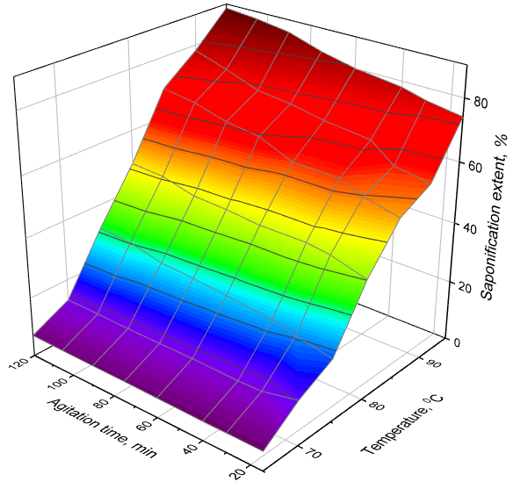
Fig. S1. Change in the saponification extent depending on the agitation time and temperature under the conditions of the conventional method.

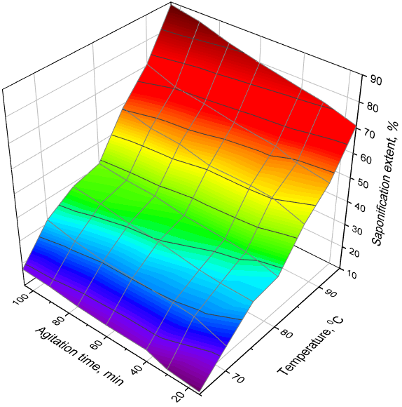
Fig. S2. Change in the degree of saponification depending on the agitation time and temperature under the conditions of the ultrasonic method.

Table S3. Comparison of experimental and calculated rate constants and residuals for conventional and ultrasonic saponification processes
Process Type | 1/T × 10⁻³ (K⁻¹) | lg K (exp) | lg K (calc) | Residual  (exp − calc)
Conventional | 2.70 | –1.30 | –1.26 | –0.04
Conventional | 2.78 | –1.38 | –1.36 | –0.02
Conventional | 2.86 | –1.50 | –1.47 | –0.03
Conventional | 2.95 | –1.62 | –1.61 | –0.01
R² = 0.969
Ultrasonic | 2.70 | –1.22 | –1.20 | –0.02
Ultrasonic | 2.78 | –1.35 | –1.33 | –0.02
Ultrasonic | 2.86 | –1.47 | –1.44 | –0.03
Ultrasonic | 2.95 | –1.58 | –1.56 | –0.02
R² = 0.9268

